

Date: 06.01.25

**TO AMSTERDAM! WEST MIDLANDS HOMEBUILDER BACKS MENTAL HEALTH CHARITY BIKE RIDE**

**For immediate release**

David Wilson Homes has sponsored the [Cameron Grant Memorial Trust’s](https://www.camgrant.org.uk/) Hampton in Arden to Amsterdam bike ride.

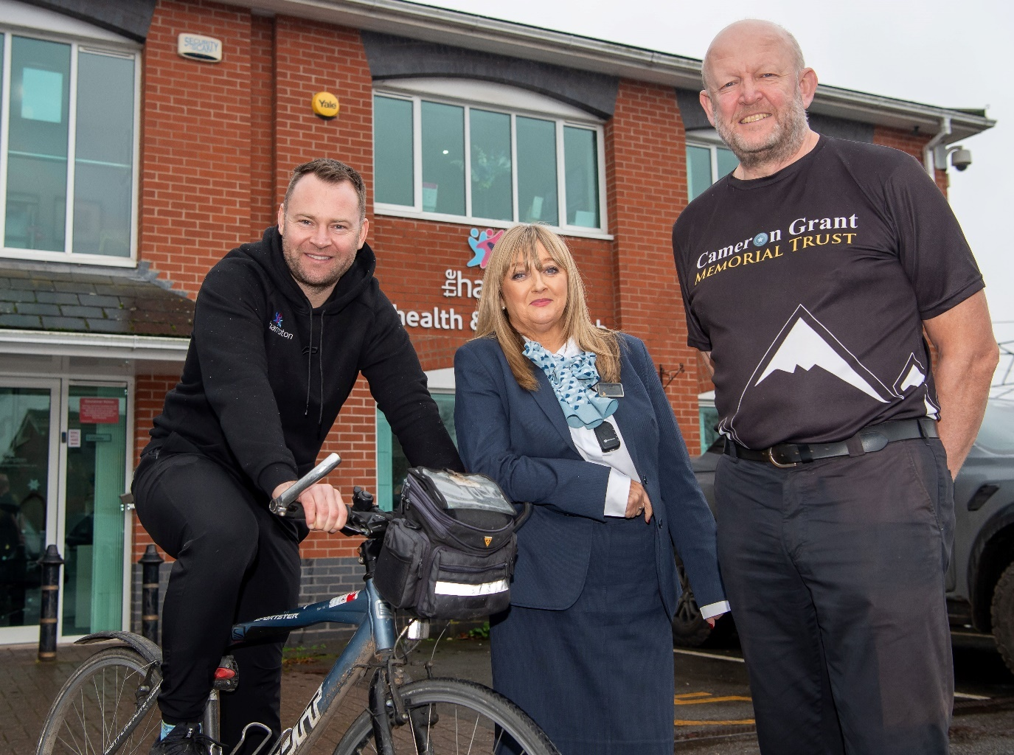

B&DWM - SGB-15090 - DWH supports charities bike ride from Hampton in Arden to Amsterdam

The mental health charity, located near David Wilson Homes’ [Ashtree Grove](https://www.dwh.co.uk/new-homes/dev-002607-ashtree-grove/) development, was founded in memory of Cameron Grant who took his own life in November 2014 at the age of 21.

The Hampton in Arden to Amsterdam bike ride will take place from Friday 16th to Monday 19th May 2025, and the Trust has joined forces with [The Hampton Health and Fitness Club](https://www.thehampton.co.uk/) to help organise the event, which will celebrate its 20th anniversary as the bike ride begins.

Cameron’s parents, Evan and Carol, alongside his brother, Alastair, created the Trust to urge anyone suffering in silence to speak up and ask for help. They do this by creating ’signposts’ with information to point those struggling in the direction of support.

These signposts might be the drinks mats known as Cameron’s Coasters, business cards, wellbeing postcards or any other kind of physical item on which help information can be printed.

Evan Grant said: “The Cameron Grant Memorial Trust has produced over 1.4 million coasters and more than 230,000 postcards and business cards. These signposts are in use across the UK.

“The Trust also makes small grants to support mental health innovation and other mental health charities. In 2024, the Trust made two grants totalling £23,000 to provide counselling support for young people in Solihull and Birmingham.”

Anybody interested in joining the Cameron Grant Memorial Trust on its adventure from Hampton in Arden to Amsterdam can find details on the [sign-up page](https://www.redfoxcycling.co.uk/event-details-registration/hampton-in-arden-to-amsterdam-cycle-challenge-may-2025-2). The Trust asks that participants pay for their accommodation and other associated costs so the money can be raised for the Trust.

Evan continued: “When Cameron died, nobody knew he was ill as he managed to hide his symptoms of depression from everyone who knew him. He suffered inside for over seven years, and we only know this from the letter he left us.

“Because Cameron bottled up all his troubles, our principal goal as the Cameron Grant Memorial Trust is to encourage anyone in mental distress, especially young people, to speak up and ask for help.

“It is hard to quantify the number of people we support, but we are confident that tens of thousands have seen Cameron’s Coasters, wellbeing postcards and other signposts, and we know that hundreds have used the keyword CAM when texting Shout 85258 for support.

Evan added: “We live in Hampton in the house where Cameron grew up, and in the village where he first went to school. As a family, we received wonderful support from the local community when Cameron died, and we still do 10 years on.”

Every year on a Friday evening close to Cameron's birthday, the family organises a night walk from Hampton through the fields to Barston and back again past Barston Lake. This has become an item in the village calendar and around 300 people take part from across Solihull and the surrounding communities.

Helen Lewis, Managing Director at David Wilson Homes Mercia, said: “We are proud to support this fantastic charity and its goal of reaching out to people in our society who are struggling in silence.”

To learn more about the charity and its Hampton in Arden to Amsterdam bike ride, visit the website at [Cameron Grant Memorial Trust](https://www.camgrant.org.uk/).

For details about any David Wilson Homes developments in the area, visit the website at [David Wilson Homes in the West Midlands](https://www.dwh.co.uk/new-homes/west-midlands/).

**ENDS**

**NOTES TO EDITORS:**

1. For further information about David Wilson Homes please contact Henry Lewis on 0116 247 1777 or [henry@unsworthsugden.co.uk](mailto:henry@unsworthsugden.co.uk)
2. David Wilson Homes is part of Barratt Developments PLC, a FTSE100 company
3. Barratt Homes was awarded a maximum five star rating for the 15th consecutive year in the 2023 Home Builders Federation Customer Satisfaction Survey
4. Site managers working for Barratt Group won 89 awards for quality workmanship in the 2024 NHBC Pride in the Job Awards. Barratt has won more Pride in the Job awards than any other housebuilder for the last 20 years
5. For further information about the Cameron Grant Memorial Trust please contact Evan Grant on 07802 245631 or [evan@camgrant.org.uk](mailto:evan@camgrant.org.uk)